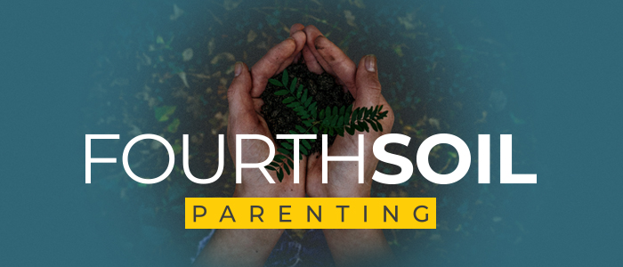

The Power of Calling for Parenting

Vibrant Faith was privileged to take part in a Lilly Grant from 2018-2021 that asked us to explore the idea of calling and vocation on the Christian life. We discovered so many things about the power of this theological idea through that work. We will be bringing much of what we learned into year two (2024) of this 4th Soil Parenting Project as we explore Parenting as a Calling.

If I am called by God to parent children, it changes everything about the role and process of parenting. One of the participants, David Greenlee from Trinity Lutheran said at our Denver training gathering, that “calling moves parenting from survival to purpose.” Yes.

Some notes for your thinking about what Vibrant Faith has learned about this important idea in Christian teaching:

- A definition of calling from Dr. Scott Curmode of Fuller Seminary is: “God’s calling to each believer is the people entrusted to your care.” This moves to focus of our callings from TASK to PERSONS.

- AND all the discipling stories that we have received chronicled in the New Testament are actually stories of calling.

- So we will be helping 4th Soil churches to help parents ask the question: How might my approach to parenting change if I see it as one of my life’s callings?

- We go into this work knowing that in Vibrant Faith’s own parenting surveys of Christian parents in churches from summer 2022 showed us that 1. Parents don’t think of parenting as a calling, so this will be a new concept for your parents. 2. Most parents want to raise their kids in the faith, but they see that as a task, not a spiritual process.

- Living into our Callings is a Spiritual Process.

